CSE370 : Database Systems
Assignment 02| Spring 2026
ID : 23241004 | Name : Afnan Mohammad Hafiz

No 1 Query  (as Plain Text) | create table employees(  e_id char(4),  first_name varchar(20),  last_name varchar(20),  hire_date date,  job_id char(10),  salary int,  commission_pct decimal(5,3),  manager_id char(4),  department_id char(3));
No 1 SS  (of Query & Output  in Shell) | 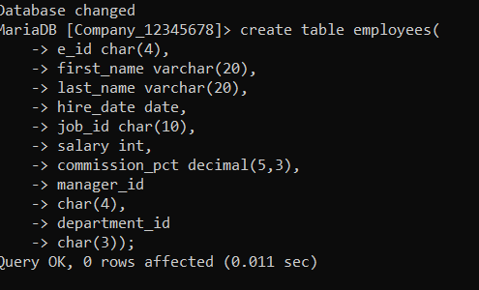
No 2 Query  (as Plain Text) | insert into employees values  ('E001','John','Doe','2020-01-15','IT_PROG',65000, NULL,'E010','D01'),  ('E002','Jane','Smith','2019-03-22','SA_REP',55000,0.150,'E011','D02'),  ('E003','Michael','Johnson','2021-06-10','IT_PROG',62000,NULL,'E010','D01'),  ('E004','Emily','Davis','2018-11-05','SA_REP',58000,0.200,'E011','D02'),  ('E005','David','Wilson','2022-02-14','IT_PROG',60000,NULL,'E010','D01'),  ('E006','Sarah','Brown','2020-07-30','HR_REP',50000,0.150,'E012','D03'),  ('E007','James','Taylor','2019-09-18','SA_REP',60000,0.180,'E011','D02'),  ('E008','Lisa','Anderson','2021-04-25','FI_ACC',52000,NULL,'E013','D04'),  ('E009','Robert','Martinez','2020-12-01','IT_PROG',67000,NULL,'E010','D01'),  ('E010','Patricia','Garcia','2017-05-10','IT_MAN',85000,NULL,NULL,'D01'),  ('E011','Thomas','Lee','2016-08-20','SA_MAN',80000,0.100,NULL,'D02'),  ('E012','Maria','White','2018-02-15','HR_MAN',75000,NULL,NULL,'D03'),  ('E013','Daniel','Harris','2019-10-30','FI_MAN',78000,NULL,NULL,'D04'),  ('E014','Jessica','Clark','2021-01-20','HR_REP',48000,0.100,'E012','D03'),  ('E015','Kevin','Lewis','2022-03-12','FI_ACC',51000,NULL,'E013','D04');
No 2 SS  (of Query & Output  in Shell) | 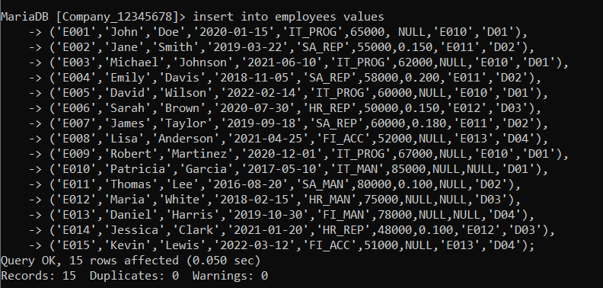
No 3 Query  (as Plain Text) | select first_name, last_name, hire_date, department_id  from employees  where hire_date=(select max(hire_date) from employees);
No 3 SS  (of Query & Output  in Shell) | 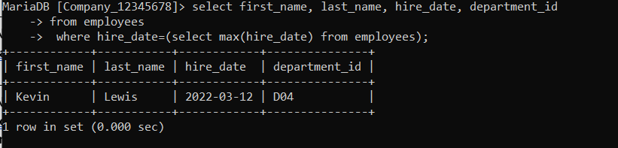
No 4 Query  (as Plain Text) | select first_name, last_name, e_id, salary, department_id  from employees  where salary=(select max(salary) from employees);
No 4 SS  (of Query & Output  in Shell) | 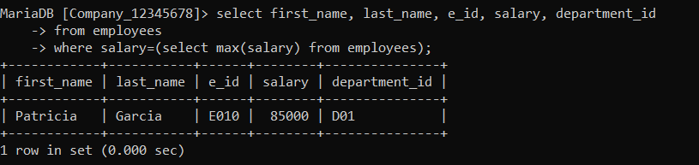
No 5 Query  (as Plain Text) | select first_name, last_name, e_id, commission_pct, department_id  from employees  where department_id='D02'and commission_pct> all(select commission_pct  from employees  where department_id='D01' and commission_pct is not null);
No 5 SS  (of Query & Output  in Shell) | 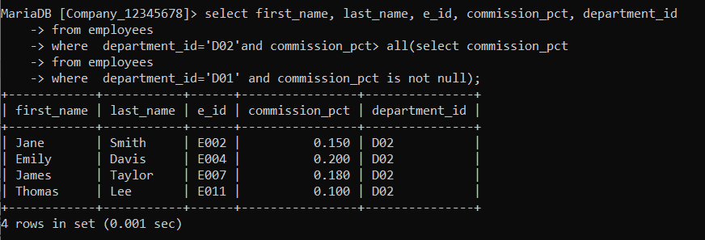
No 6 Query  (as Plain Text) | select department_id, count(*)  from employees  group by department_id  having max(salary) <=70000
No 6 SS  (of Query & Output  in Shell) | 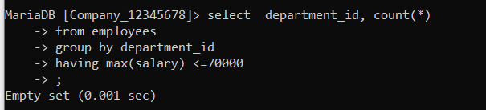
No 7 Query  (as Plain Text) | select department_id, job_id, salary  from employees  where salary < any(select salary  from employees  where department_id= employees. department_id);
No 7 SS  (of Query & Output  in Shell) | 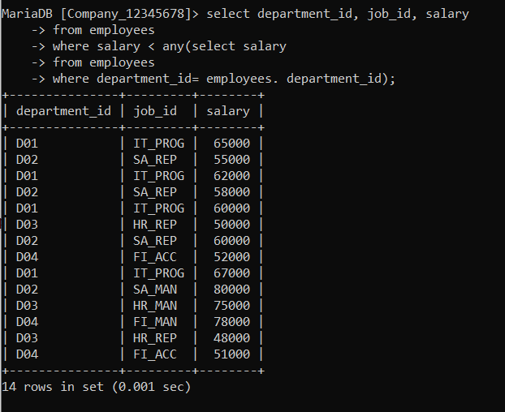
No 8 Query  (as Plain Text) | select distinct manager_id  from employees e1  where manager_id is not null  and not exists (select *  from employees e2  where e2.manager_id = e1.manager_id  and e2.salary<55000);
No 8 SS  (of Query & Output  in Shell) | 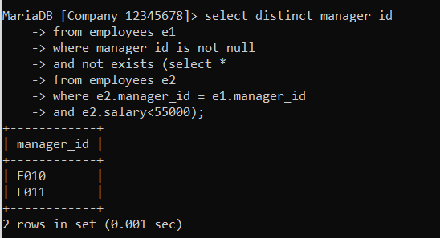
No 9 Query  (as Plain Text) | select first_name, last_name, e_id, salary, department_id, commission_pct  from employees  where commission_pct = (select max(commission_pct)  from employees  where manager_id=employees. manager_id);
No 9 SS  (of Query & Output  in Shell) | 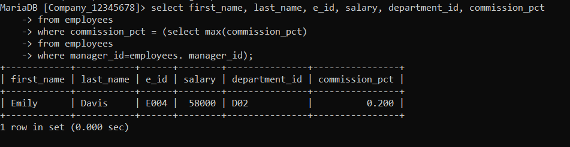
No 10 Query  (as Plain Text) | select job_id, avg(salary)  from employees  group by job_id  having avg(salary)< (select avg(salary)  from employees);
No 10 SS  (of Query & Output  in Shell) | 